***Project Name 3***

***Integrate Grafana with Linux server for high utilization and make a graph in grafana***



Step 1- Creating a EC2 instance

* Login in to your aws account.
* Go to search bar search Ec2.

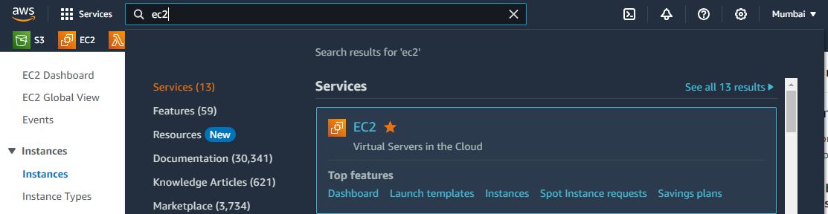

* Go to the launch instance.
* Give a instance name-***linuxserver.***

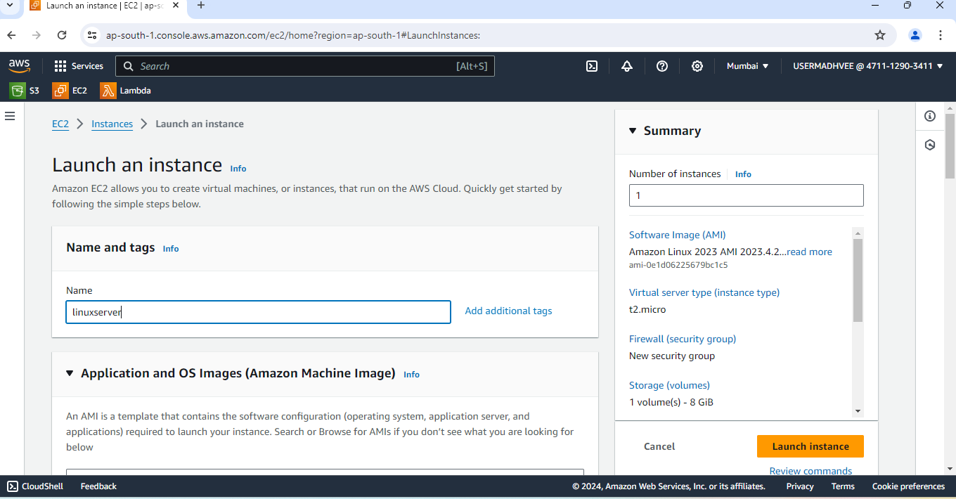

* Choose ***ubuntu.***

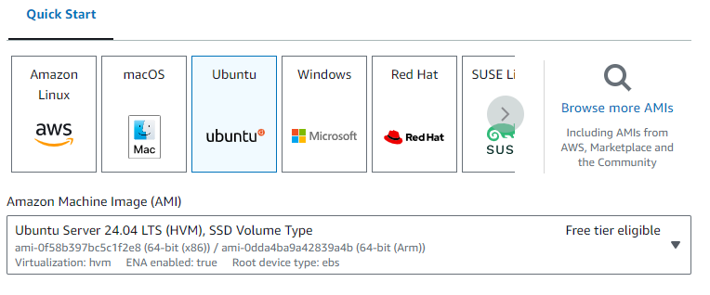

* Create a key pair .

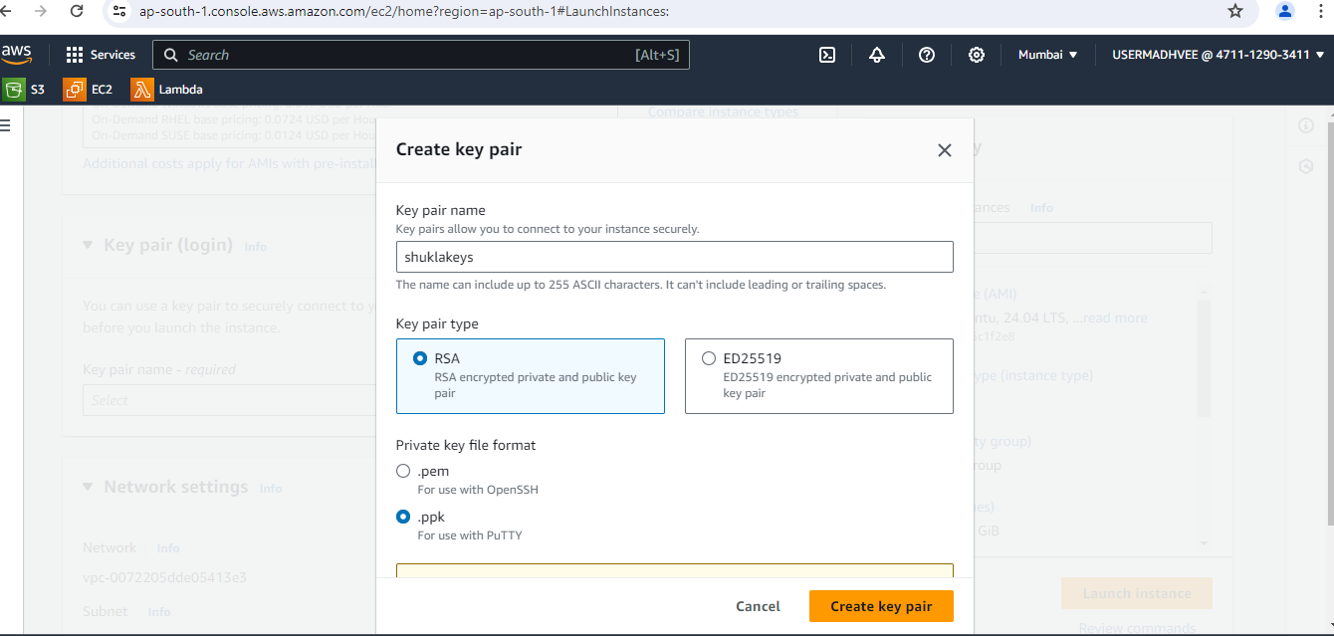

* Now your instance is created.

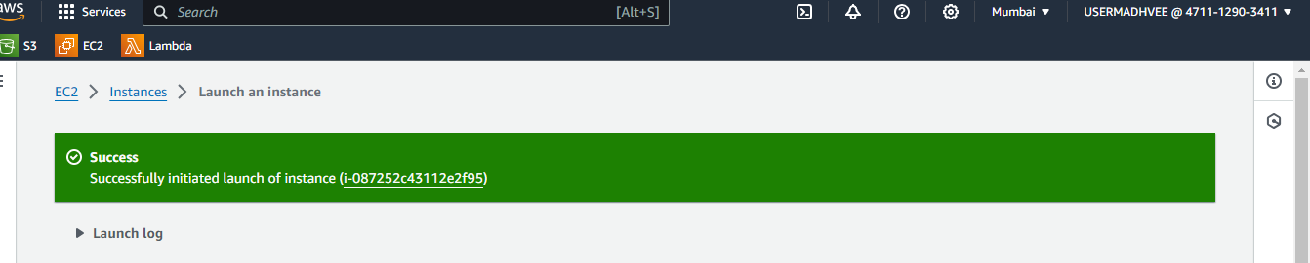

* Click on EC2 instance. Go to security and select security group.
* Edit inbound rule. Delete predefined rule.

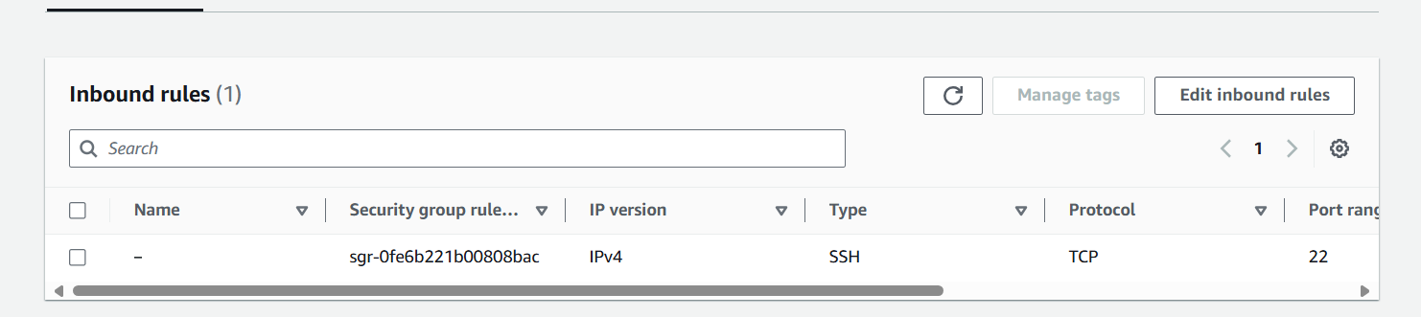

* Add a new rule and select Type- All traffic.
* And source- IPv4. Save changes.

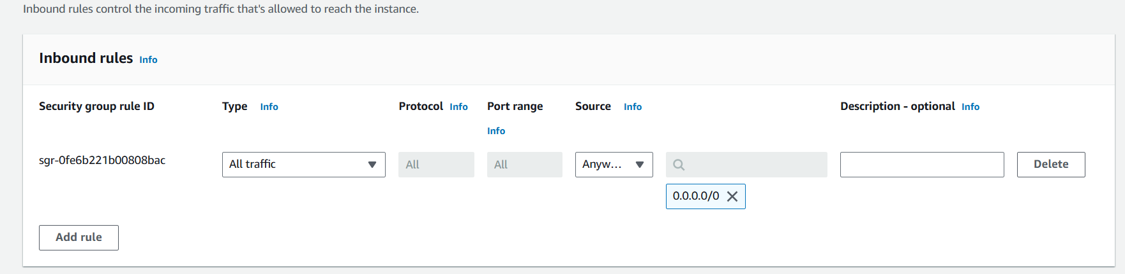

* Save else as default.
* Now copy the public ipv4 address.

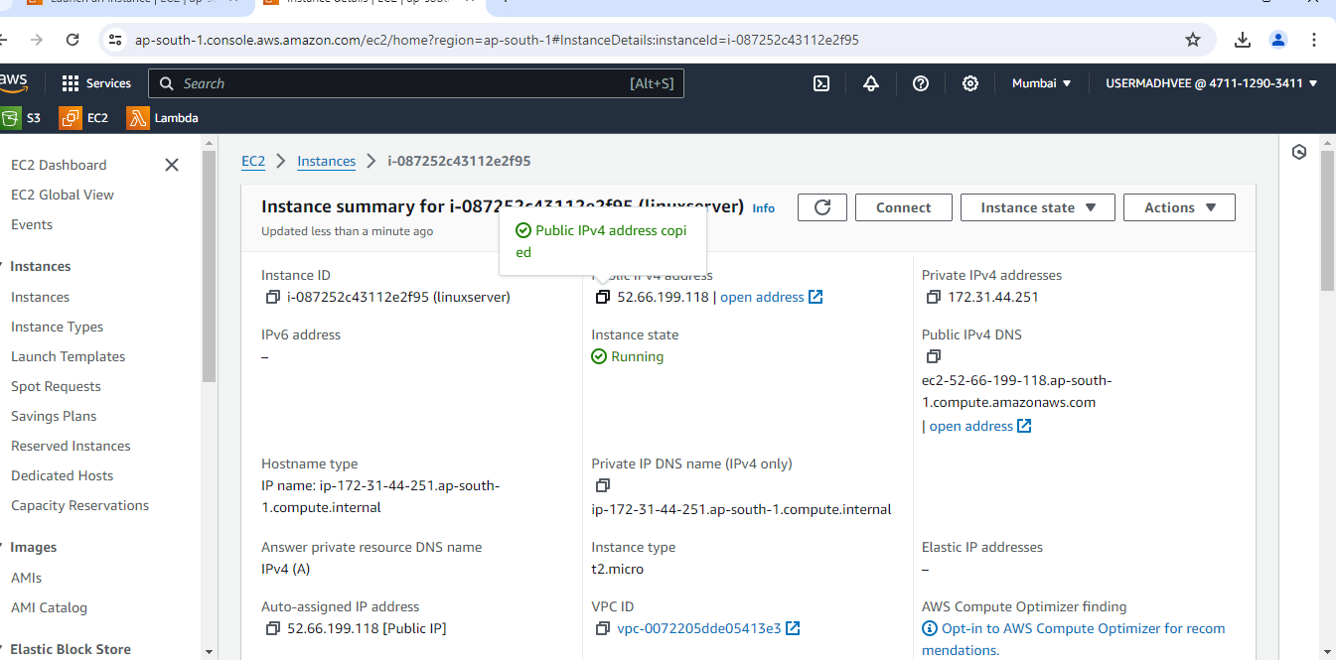

* Go to the putty and copy this address.
* SSH->Auth->credential then browseyour key.
* Login as ubuntu.

Switch to root user using – sudo -i. 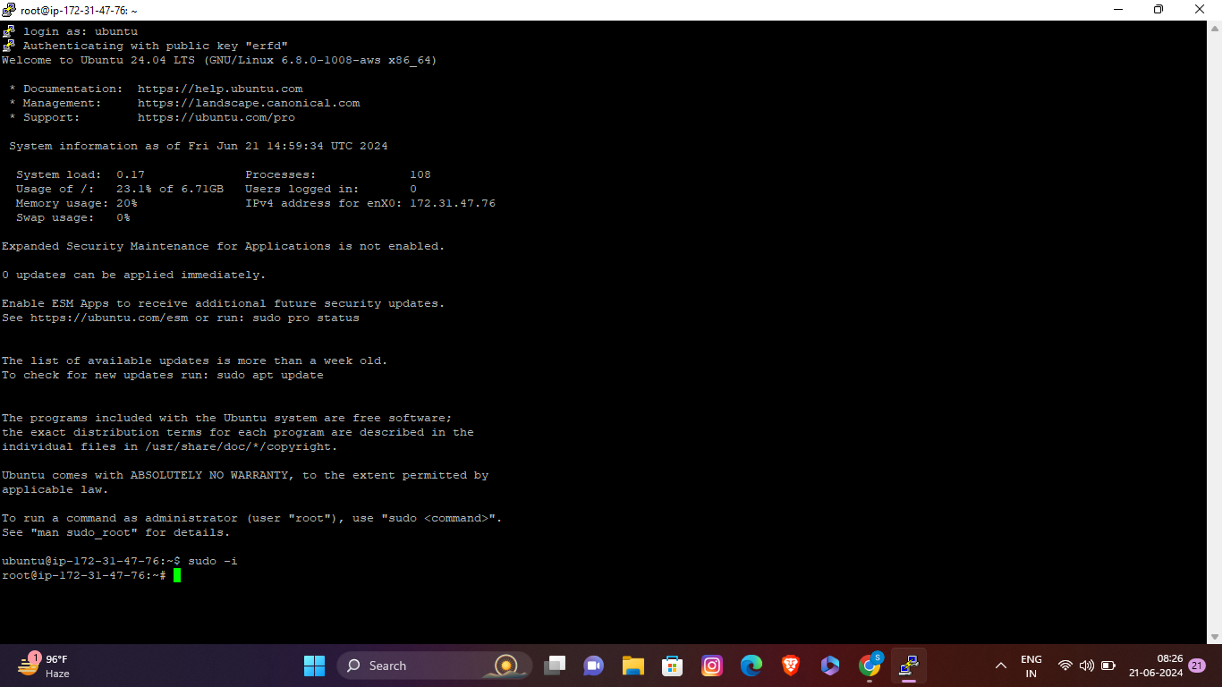

Step 2-Install Prometheus

* Install Prometheus using these commands.
  + wget<https://github.com/prometheus/prometheus/releases/download/v2.53.0/prometheus-2.53.0.linux-amd64.tar.gz>
* To view installation run “ls” command.
* Create file using this command.
  + ***tar xzf prometheus-2.53.0.linux-amd64.tar.gz***
* Check file is created by ls command.
* Move the file using -***mv prometheus-2.53.0.linux-amd64 /etc/prometheus***
* Run -***nano /etc/systemd/system/prometheus.service***

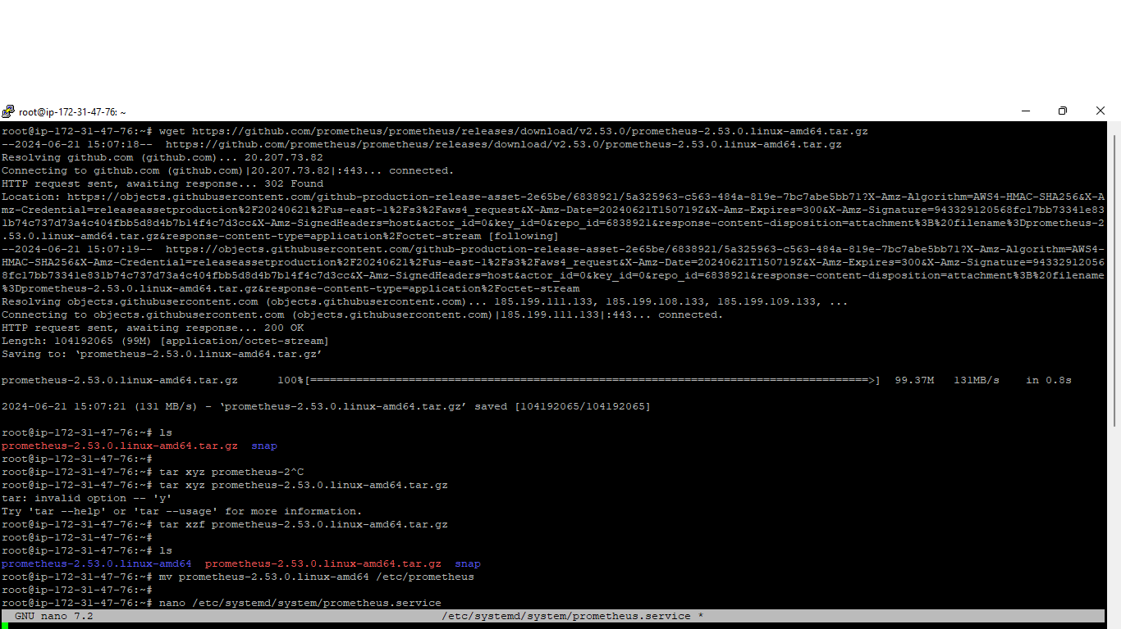

* Enter this into file

[Unit]

Description=Prometheus

Wants=network-online.target

After=network-online.target

[Service]

ExecStart=/etc/prometheus/

prometheus --config.file=/etc/

prometheus/prometheus.yml

Restart=always

[Install]

WantedBy=multi-user.target

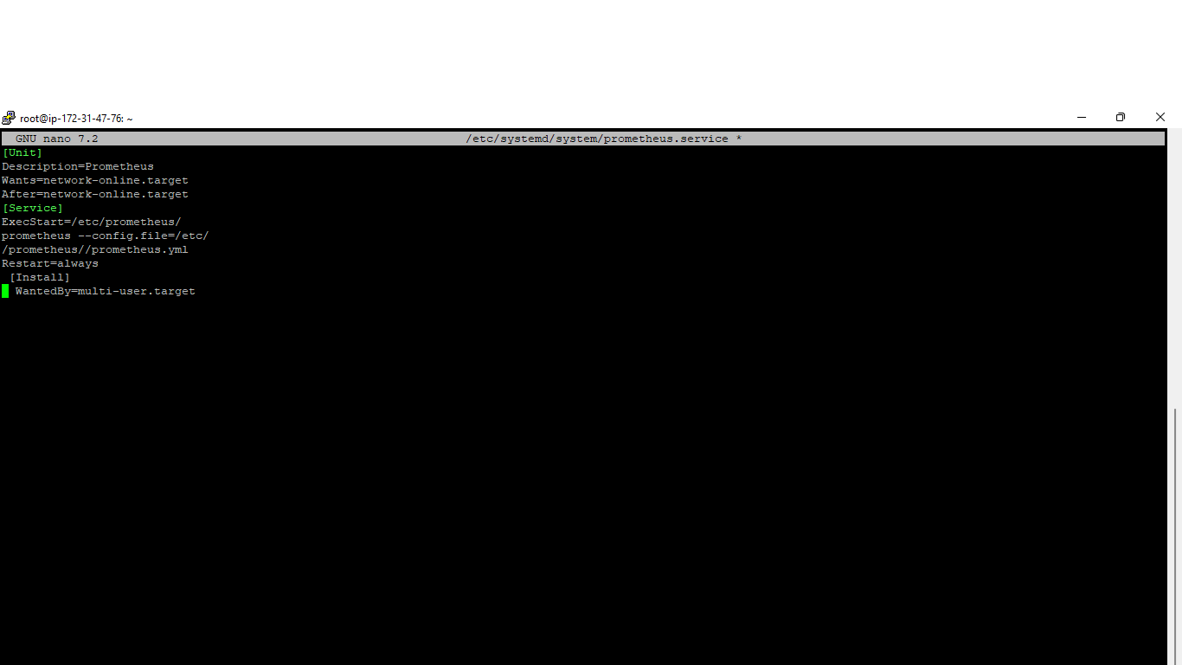

* Save it using crtl+O, press enter.
* Exit using Ctrl+X.
* Run these command.
  + *systemctl daemon-reload*
  + *systemctl restart prometheus*
  + *systemctl enable prometheus*
* Check status using
  + ***systemctl statusprometheus***
* Make sure the status is Active.
* Open the web UI using public IP with 9090 port. <http://intsanceip:9090>
* You will see a Prometheus UI.

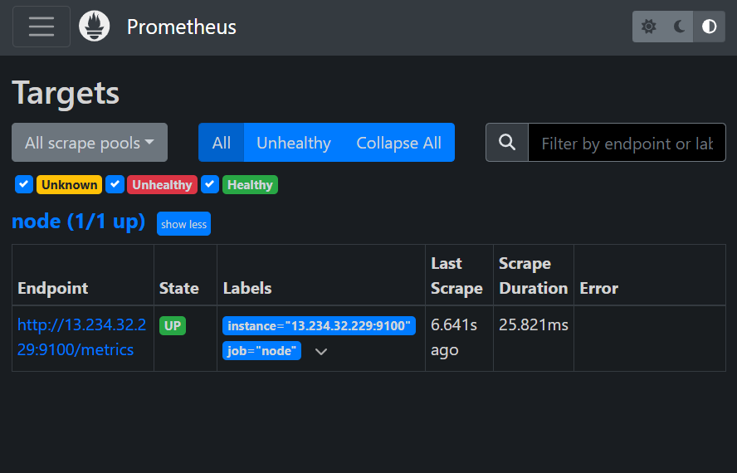

* Make sure the status is showing UP.

Step 3-Installing node exporter

* Install node exporter using this command
  + wget<https://github.com/prometheus/node_exporter/releases/download/v1.8.1/node_exporter-1.8.1.linux-amd64.tar.gz>
* Run these commands
  + *-ls*
  + *-tar xzf node_exporter-1.8.1.linux-amd64.tar.gz*
  + *-ls*
  + *-mv node_exporter-1.8.1.linux-amd64 /etc/node_exporter*
  + *-nano etc/systemd/system/node_exporter.service*
  + *-mv node_exporter-1.8.1.linux-amd64 /etc/node_exporter*
  + *-nanoetc/systemd/system/node_exporter.service*
* Enter this in file

[Unit]

Description=Node Exporter

Wants=network-online.target

After=network-online.target

[Service]

ExecStart=/etc/node_exporter/node_exporter

Restart=always

[Install]

WantedBy=multi-user.target

* Restart and enable node exporter. Check status is active
  + *systemctl daemon-reload*
* *systemctl restart node_exporter*
* *systemctl enable node_exporter*
  + *systemctl status node_exporter*
* Edit Prometheus scrap file using.
  + ***rm -rf /etc/prometheus/prometheus.yml***
  + ***nano /etc/prometheus/prometheus.yml***
* Enter this in file
  + global:
  + scrape_interval: 15s
  + scrape_configs:
    - job_name: node
  + static_configs:
    - targets: ['localhost:9100'

]

* Replace local host with your IP. Save and exit.
* check status is active.
  + ***systemctl restart prometheus***
  + ***systemctl status prometheus***
* In Prometheus web Ui you see in target section 1 node with UP status.



Step 4-Install Grafana

* Install Grafana using these command.
  + *sudo apt-get install -y software-properties-common*
  + *sudo add-apt-repository "deb https://packages.grafana.com/oss/deb stable main"*
* sudo apt-get install -y gnupg2
  + *sudo apt-key adv --fetch-keys* [*https://packages.grafana.com/gpg.key*](https://packages.grafana.com/gpg.key)
  + *sudo apt update*
  + *sudo apt install grafana*
* Enable and check status.
  + *sudosystemctl start grafana-server*
  + *sudosystemctl enable grafana-server*
  + *systemctl status grafana-server*
* Open Grafana web ui using ip address with 3000 port. <http://instanceip:3000>



* You will see this window in web.
* Enter email-admin and password admin.
* Set new password.
* Click on menu in the top left corner.
* Go to connections and add new connections search prometheus data source.

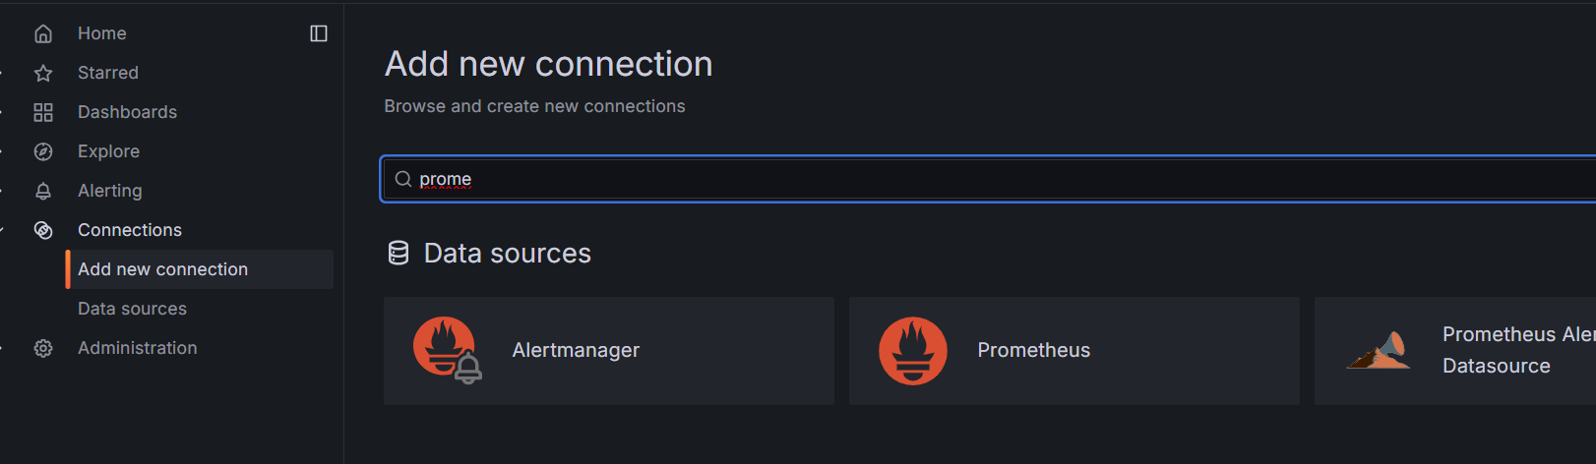

* Paste your prometheusurl in url section.

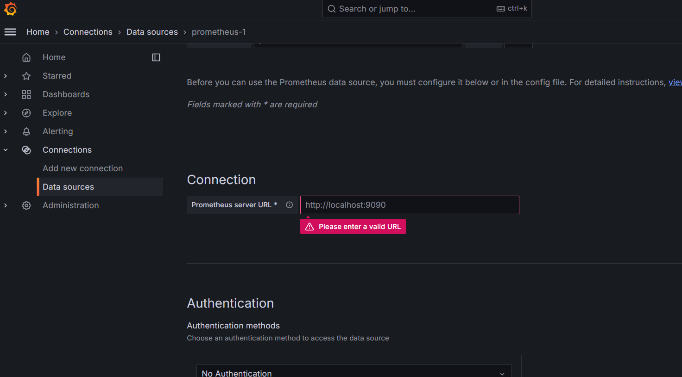

* Leave else as default and save it.
* Now go to dash board. Add new dashboard and enter the same as shown in the image

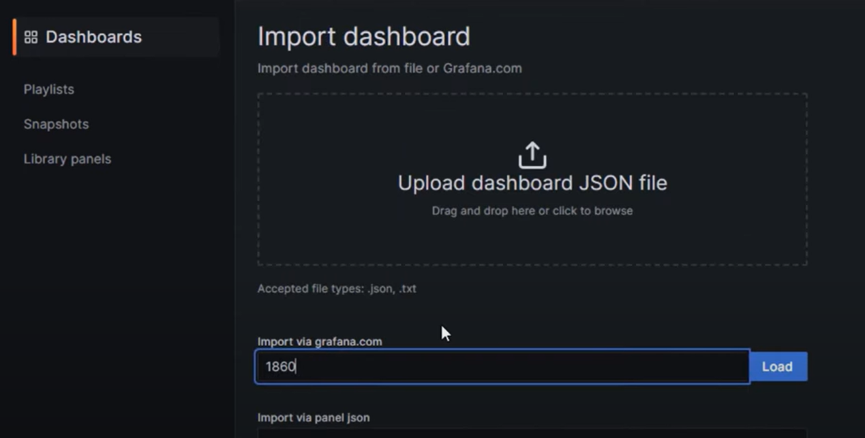

* You will see a new added dashboard.

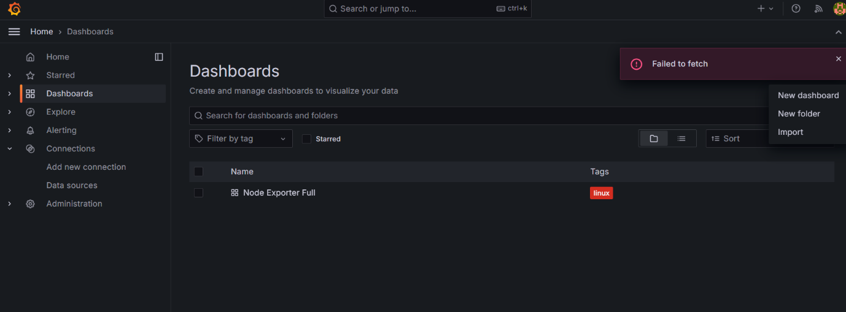

* Goto setting in links section add dashboard link.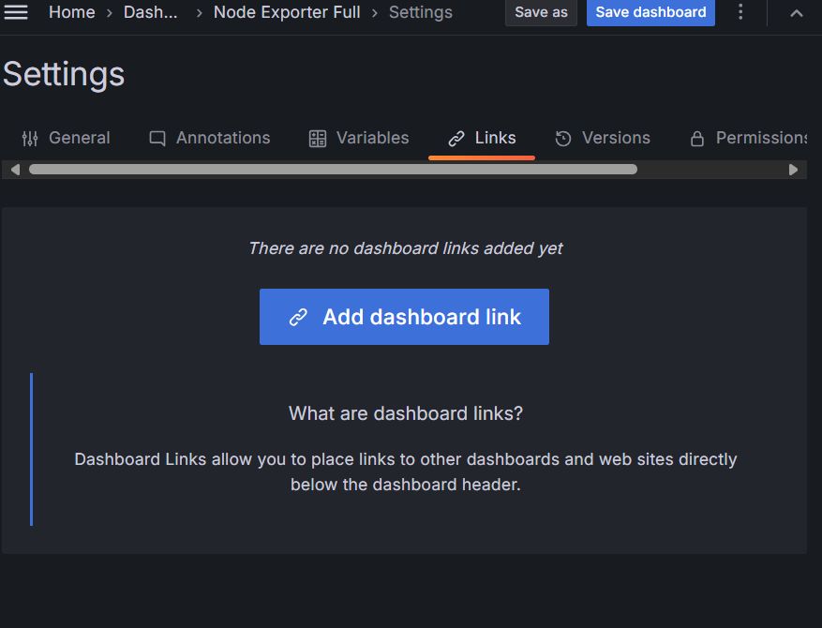
* You will see this dashboard.

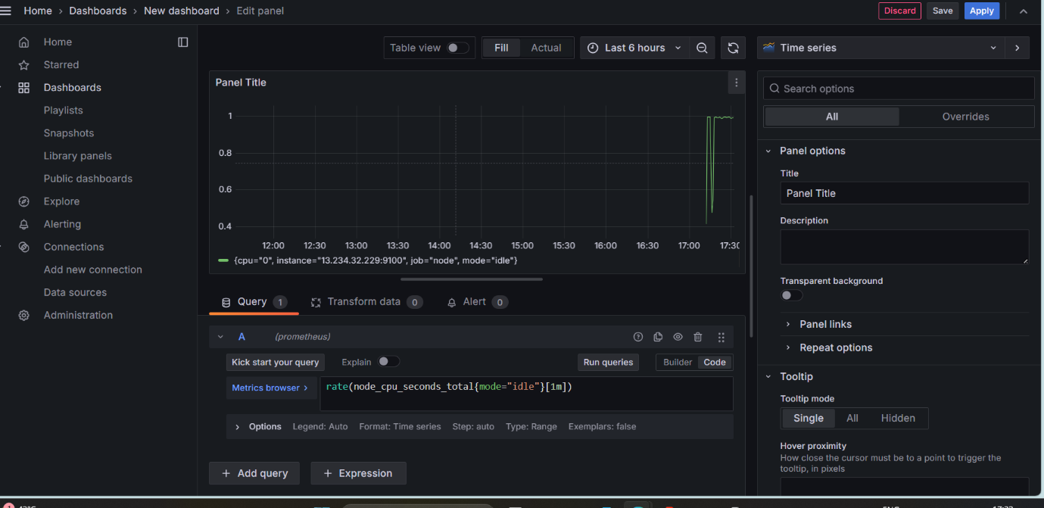

* In query section run this query as shown in image.
* In your linux instance run stress command
  + ***sudo apt install stress***
  + ***stress --cpu 4 --timeout 300***
* Now you can see graph in Grafana dashboard.

